

|  |  |  |
| --- | --- | --- |
|  | **Mathematics Department**  **11 Maths Methods Test 5 Even**  **Indices, Sequences and Trigonometric Identities** | |
| **Name** |  |

**Section 1 – Resource Free – Students can have the formula sheet**

**Marks : 30 Time: 32 minutes (maximum)**

**1. [2, 3 = 5 marks]**

Simplify the following (expressing with positive indices):

(a)  (b) 

**2. [3, 4 = 7 marks]**

Solve the following equations

a) 91-x = 27x-2.3x+2 b) 2x + y = 10 and 253x + y = 6252

**3. [3, 1, 3 = 7 marks]**

a) Find the exact value of sin (-15°) (no need to rationalise denominators)

b) Given that sin A =  and tan B = , where A is acute and 180° < B < 270°

Find:

i) cos A ii) cos (A – B)

**4. [4 marks]**

Graph y = 2cos3x + 1 0° ≤ x ≤ 360°

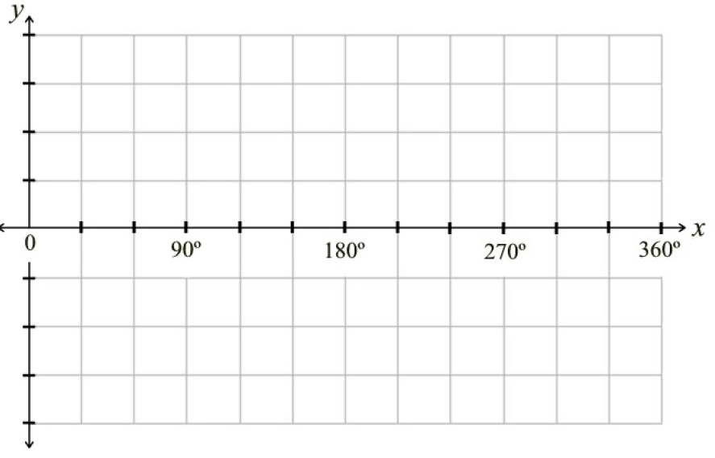

**5. [3 marks]**

Prove the **identities**:



**6. [4 marks]**

If **t**10 = 100 and **t**15 = 175, find the first term and the common difference the given the terms are an arithmetic progression.



|  |  |  |
| --- | --- | --- |
|  | **Mathematics Department**  **11 Maths Methods Test 5 Odd**  **Indices, Sequences and Trigonometric Identities** | |
| **Name** |  |

**Section 2 – Resource Rich – calculators, formula sheet and 1 page of notes**

**Marks : 25 Time: 27 minutes (minimum)**

**7. [1, 1, 1, 2, 2 = 7 marks]**

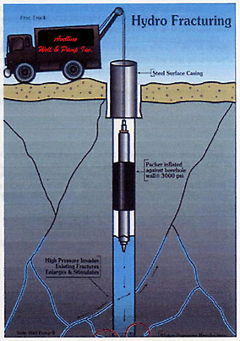

Drilling tests show that in sinking a well, the distance drilled each hour

decreases by 10%. A depth of 20 metres is drilled in the first hour.

1. Find how much is drilled in the second and third hours.

[1]

1. Explain why the distances drilled each hour will form a geometric progression.

[1]

1. Find the distance drilled in the 10th hour, correct to the nearest centimetre.

[1]

1. How long will it take to drill a depth of 100 metres? (answer to the nearest minute)

[2]

1. The contractors estimate that the gas they are looking for is somewhere between 250 and 300m below ground? When would they expect to first find the gas? Some justification is required for this question.

[2]

**8. [2, 1, 2 = 5 marks]**

Amy is left a sum of $ 460 000 in a will and considers investing the money in a bank account paying 6.25% **pa** interest compounded annually. She wants to withdraw $ 40 000 per year for living expenses.

a) Write a **recursive set** of equations for this information.

b) For how many years will she be able to withdraw this amount from the account?

c) If she wanted her money to last about 40 years, approximately how much could she take out each year? (Some justification is needed for your answer,)

**9 [3 marks]**

A hiker sets out on a 100km hike. She walks 36 km on the first day and  that distance on the second. Every day thereafter she walks  of the distance she walked on the day before.

Will the hiker cover the distance of 100 km to complete the walk and if so, on what day will she complete the task?

**10. [2, 2 = 4 marks]**

a) Insert four evenly spaced numbers between 8 and 36.

b) Insert three numbers between 4 and 2500 so that they are in geometric progression.

**11. [4 marks]**

Find the sum of all powers of 2 between 500 and 50000.

**12. [2 marks]**

Solve **3 - 2cos(3x + ) = 1** π ≤ x ≤ 3π (accurate to 3 significant figures)